Washington County 4-H
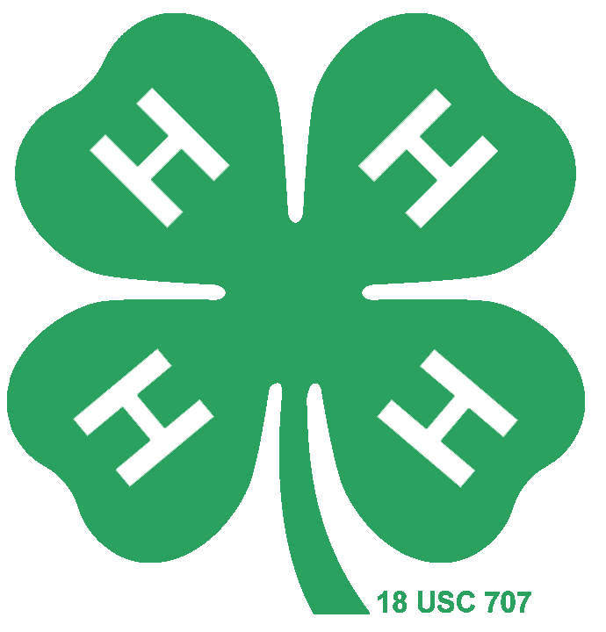
OSU Extension Service
1815 NW 169th Pl, #1000
Beaverton, Oregon 97006

P 503-821-1119
http://wash4h.org

4-H Travel Grant Application – 2024-2025

Washington County 4-H Association is pleased to offer 4-H Youth Travel Grants. These grants provide financial assistance for 4-H members to participate in and contribute to a 4-H sponsored event or an event that directly relates to a youth’s project. A maximum of $400 is available per quarter ( Jan -Mar; Apr- Jun; July- Sept; Oct- Dec). Funds are allocated on a first come, first serve basis. Only one grant will be awarded per person during each fiscal year. Any currently enrolled 4-H member in Washington or Multnomah counties is eligible to apply after qualifying to attend the event. The application is due at least six weeks before event. If an extenuating circumstance occurs where there is less than six weeks before the event a youth would need to contact the committee to discuss the situation to see if there would be enough time to get a grant approved for funding.

Review Process: All applications will be reviewed by an interview subcommittee consisting of three or more members. The subcommittee will review the application and set up a zoom meeting for the applicant to give a five-minute presentation explaining their application. Applicants will be notified of the decision by e-mail and phone call within one week of a presentation.

Funded applicants will also present a final presentation at an advisory meeting that represents their project (Small Animals, Livestock, HEARTH, Horse, Awards & Recognition). This presentation will be recorded so it can be used to promote the Youth Travel Grant program.

Please answer the following questions as appropriate, to describe your project. Use additional pages to complete application.
Incomplete applications will not be considered for funding.

Application must be completed by the youth

For any questions regarding the application or the process please contact Debbie Coe at debbiecoe1240@comcast.net

Please send completed application to WashCo4HAssociation@gmail.com

Applicant Name: _______

Contact Address:

City: _______ State: Zip:

Day Phone: ___ Evening Phone:

E-mail Address:

Club Name: __________________________

Event:________ Date(s) Held

Youth Signature ________________________________________________________________
By signing, I certify I completed the application and all the information is accurate.

Parent Signature ________________________________________________________________

Essay prompts: Attach a document answering each of the following questions. Minimum of ½ page per prompt.

- Describe the event you would like to attend. Include the steps you have taken to qualify for it (if applicable), how much money you are requesting, and explain how this grant will be used to help you get there. If available include a brochure or other promotional information.
- Describe how you believe attending this event will benefit you, your club and program. Be sure to include specific educational opportunities this event will provide.
- Itemize the expenses that you are requesting to be covered by the funding. Describe what fundraising you have done and how much was earned. If matching funds are being used to help to assist in financing this event, please list them and their sources.

If grant is approved, please attach the completed payment voucher for the check.

Project Budget Worksheet:

Expenses: | $
Total Cost: | $

Income Source: | $:
Total Income: | $

